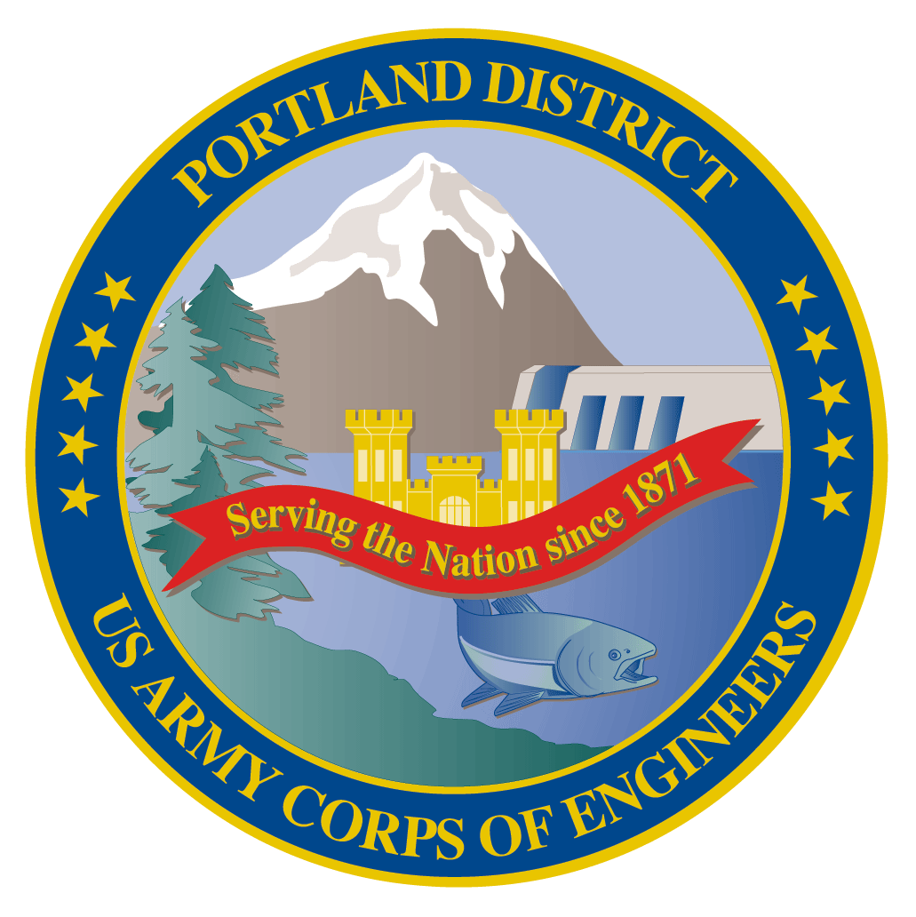
Lower Columbia River Fish Facility Design Review Work Group (FFDRWG)

USACE, Portland District

June 2021 Meeting Agenda
June 3, 2021 09:00-11:00
Join Meeting: https://usace1.webex.com/usace1/j.php?MTID=m5c365c1bf762dad74cbaa2985e8e04fb
Meeting password: FFDRwG2021!
(*if using your phone for audio, log in through Webex and have the meeting call you)

Join by phone (audio only, no Webex): (844) 800-2712 | Access Code: 199 571 1422

Introductions
FFDRWG members:
BPA
Scott Bettin
Kim Johnson
Siena Lopez-Johnston
Christine Petersen
Greg Smith
Leah Sullivan
Ben Hausmann
NOAA
Blane Bellerud
Gabriel Brooks
Trevor Conder
Kinsey Frick
Claire McGrath
Josie Thompson
Logan Negherbon
USFWS
Dave Swank
States
Erick Van Dyke (ODFW)
Charles Morrill (WDFW)
CRITFC/Tribes
Tom Lorz (CRITFC)
Blaine Parker (CRITFC)
Tom Skiles (CRITFC)
Casey Baldwin (CTCR)
Michael Karnosh (CTGR)
Lawrence Schwabe (CTGR)
Torey Wakeland (CTGR)
Aaron Jackson (CTUIR)
Ralph Lampman (YN)
NPCC
Leslie Bach
Kris Homel
FPC
Erin Cooper
PSMFC
Alan Brower
Darren Chase
Roger Clark
Mark Leonard
Scott Livingston
Nicole Tancreto
Don Warf
CENWD
Doug Baus
Tim Dykstra
Dan Feil
Mike Langeslay
Cindy Studebaker
Sean Tackley
Lisa Wright
CENWW
Karl Anderson
Chris Peery
Marvin Shutters
Denise Griffith
CENWP-OD
Andrew Derugin
Rebecca Cates
Jeanette Wendler
Bob Cordie
Jeffrey Randall
Scott Fielding
Eric Grosvenor
Michael Lotspeich
Laura Rickets
Tammy Mackey
Darren Gallion
Nathan McClain
Robert Wertheimer
Karrie Gibbons
CENWP-PM
Jim Adams
Eric Bluhm
Ian Chane
Jeff Hicks
Steve Sipe
Bob Winters
Brad Eppard
David Griffith
Fenton Khan
Rachel Laird
Jake Macdonald
Rich Piaskowski
Jon Rerecich
Ida Royer
David Trachtenbarg
Jeremiah Woodard
Erin Kovalchuk
CENWP-ENC
Adam White
Brandt Bannister
Bridget Bell
Jonathon Brink-Roby
Shari Dunlop
Laurie Ebner
Curtis Lipski
Chris Motti
Steve Schlenker
Max Wilson-Fey
Mehdi Roshani

Action items from last meeting
- Weiland et al (2016) was sent to FFDRWD by Jake Macdonald on 5/14 (relevant to discussion over Bonneville spillway survival)
- Axel et al (2020) was sent to FFDRWD by Christine Petersen on 5/6 and Jake Macdonald on 5/14 (relevant to discussion over the PIT barge at Bonneville)

Topics for FFDRWG Discussion/Review/Coordination
- BON spillway rock removal/mitigation – Jeremiah Woodard (PM), Max Wilson-Fey (TL), Jacob Macdonald (FC)
  - Draft modeling report was sent to FFDRWG by Jake Macdonald on 6/1. Questions/comments?
- BON adult lamprey passage improvements: Washington Shore control section redesign – Bob Winters (PM), Shari Dunlop (TL), Jacob Macdonald (FC)
  - Scope update
- BON adult lamprey passage improvements: Bradford Island Ladder extensive minor modifications to serpentine section for lamprey – Bob Winters (PM), Adam White (TL), Jacob Macdonald (FC)
  - FFDRWG input on scope/scale
- JDA adult lamprey passage improvements: North Fish Ladder LPS water supply upgrade – Eric Bluhm (PM), Adam White (TL), Jacob Macdonald (FC)
  - Water supply (gravity fed?)
- TDA adult lamprey passage improvements: East Fish Ladder junction pool LPS – Eric Bluhm (PM), Adam White (TL), Jacob Macdonald (FC)
  - Water supply (gravity fed?)

Written project updates
- JDA turbine rehab – Steve Sipe (PM), Curtis Lipski (TL), Jon Rerecich (FC)
- TDA AWS Debris Management– Erin Kovalchuk (PM), Mehdi Roshani (TL), Jon Rerecich (FC)
- BON Second Powerhouse FGE – Jim Adams (PM), Bridget Bell (TL), Jon Rerecich (FC)
- JDA adult lamprey passage improvements: South Ladder entrance improvements (rounded crest, slot filler) – Eric Bluhm (PM), Adam White (TL), Jacob Macdonald (FC)
- TDA adult lamprey passage improvements: East Fish Ladder control section weir modifications – Eric Bluhm (PM), Adam White (TL), Jacob Macdonald (FC)
- BON adult lamprey passage improvements: LPS pump upgrades – Bob Winters (PM), Andrew Derugin (TL), Andrew Derugin (FC)
- BON adult lamprey passage improvements: Bradford Island B-Branch entrance improvements (variable width entrance weir, bollards, and transition pool LPS) – Bob Winters (PM), Adam White (TL), Andrew Derugin (FC)
- BON adult lamprey passage improvements: Cascades Island LPS flume modifications – Bob Winters (PM), Andrew Derugin (TL), Andrew Derugin (FC)

Next meeting: July 1st @ 09:00

